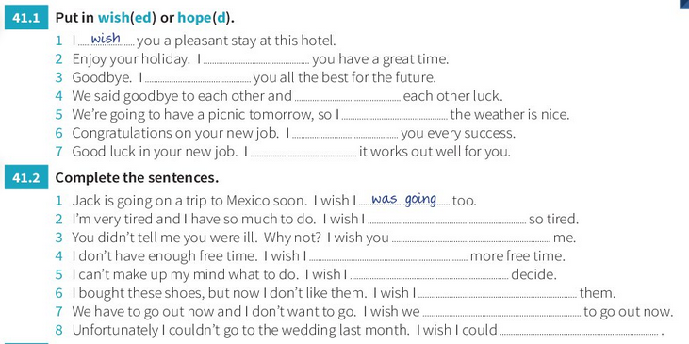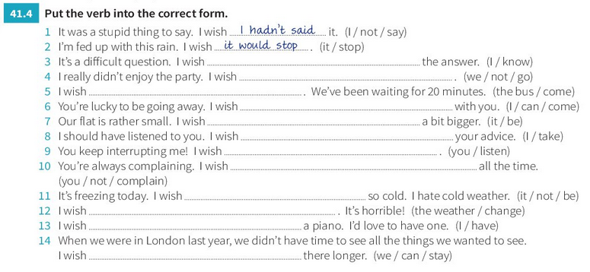

**Zero conditional sentence** with two [present simple](https://www.perfect-english-grammar.com/present-simple.html) verbs:

If + present simple, .... present simple.

**USE:** when the result will always happen.

**Ex.: If water reaches 100 degrees, it always boils.**

(It is always true, there can't be a different result sometimes).

**Ex.: If I eat peanuts, I am sick.**

(This is true only for me, maybe, not for everyone, but it's still true that I'm sick every time I eat peanuts)

If people **eat** too much, they **get** fat.

If you **touch** a fire, you **get** burned.

People **die** if they **don't eat**.

You **get** water if you **mix** hydrogen and oxygen.

Snakes **bite** if they **are** scared.

If babies **are** hungry, they **cry**



**Zero conditional sentence** with two [present simple](https://www.perfect-english-grammar.com/present-simple.html) verbs:

If + present simple, .... present simple.

**USE:** when the result will always happen.

**Ex.: If water reaches 100 degrees, it always boils.**

(It is always true, there can't be a different result sometimes).

**Ex.: If I eat peanuts, I am sick.**

(This is true only for me, maybe, not for everyone, but it's still true that I'm sick every time I eat peanuts)

If people **eat** too much, they **get** fat.

If you **touch** a fire, you **get** burned.

People **die** if they **don't eat**.

You **get** water if you **mix** hydrogen and oxygen.

Snakes **bite** if they **are** scared

If babies **are** hungry, they **cry**